Effect of COVID-19 on the real estate market in Tier-I and Tier-II cities in India

Abstract:

With more and more companies allowing their work force to work from home either permanently or for prolonged period of time during COVID-19. The migration of friends and colleagues to their home towns was a common phenomenon after lifting of complete lockdown.

Major IT hubs are situated in the Tier-I cities like Bengaluru, Mumbai etc. and most are the work force is from the Tier-II cities like Ranchi, Patna, Lucknow etc. So, the migration was from Tier-I to Tier-II cities. The effect of this was clearly seen on the dip of prices of the real estate prices including both buying and renting of a property.

After the strict lock down was over it has been observed that there was a sharp increase in the prices, but post that once migration started and people were allowed to move there was a clear dip in the real estate price.

We have decided to apply traditional machine learning methods such as linear regression, Clustering to forecast or predict the price variation and use this as a tool to get insights about the real estate market. This can also be helpful for investors to take informed decision before investing in real estate market.

We would try to incorporate sentiments analysis, for which we would collect data from either twitter or google to validate our observations.

Introduction:

In this paper we are focusing on the impact of this migration on the real estate prices in the Tier-I and Tier-II cities, due to COVID-19 by observing the trend of prices of real estate in Tier-I cities categorized by Govt. of India. Under the latest HRA city ranking scheme, most popular media and culture considers only tier-X (Tier-I) cities to be metropolitan in nature. These eight cities are considered India's "metros".

|  |  |
| --- | --- |
| **HRA classification** | **City** |
| **X** | Ahmedabad, Bengaluru, Chennai, Delhi, Hyderabad, Kolkata, Mumbai and Pune |
| **Y** | Agra, Ajmer, Aligarh, Amravati, Amritsar, Asansol, Aurangabad, Bareilly, Belgaum, Bhavnagar, Bhiwandi, Bhopal, Bhubaneswar, Bikaner, Bilaspur, Bokaro Steel City, Chandigarh, Coimbatore, Cuttack, Dehradun, Dhanbad, Bhilai, Durgapur, Dindigul, Erode, Faridabad, Firozabad, Ghaziabad, Gorakhpur, Gulbarga, Guntur, Gwalior, Gurgaon, Guwahati, Hamirpur, Hubli–Dharwad, etc… |

Machine learning (ML) is the study of computer algorithms that improve automatically through experience. It is seen as a subset of artificial intelligence. Machine learning algorithms build a model based on sample data, known as "training data", in order to make predictions or decisions without being explicitly programmed to do so.

A supervised learning algorithm analyzes the training data and produces an inferred function, which can be used for mapping new examples. This requires the learning algorithm to generalize from the training data to unseen situations in a "reasonable" way (see inductive bias). Linear regression is a type of supervised learning algorithms, where the learning function predicts the continues value.

In our analysis we have come up with following features which may represent the mapping of the continues price values.

|  |  |  |  |
| --- | --- | --- | --- |
| 1. | Posted Date | 4. | No. of Bed Rooms |
| 2. | City | 5. | No. of Balconies |
| 3. | Carpet Area | 6. | No. of Amenities |

In this paper, we want to focus on the impact of COVID-19, on the real estate prices using linear regression, random forest, XG-Boost regression, time series and nowcasting. To prove our hypothesis, we will be using real data which will be extracted from property websites like “**Makaan** (https://www.makaan.com/) “etc. We will be scrapping data in 3 sets i.e. pre-complete lockdown, during lockdown and post lockdown.

Instead of forecasting for longer period we have decided to forecast for shorter period where we can validate our hypothesis. Initial phase of our work will involve data gathering, data cleaning, doing exploratory data analysis, applying machine learning techniques and documenting our findings. We expect one and half month of time to complete all the above said tasks.

Summary:

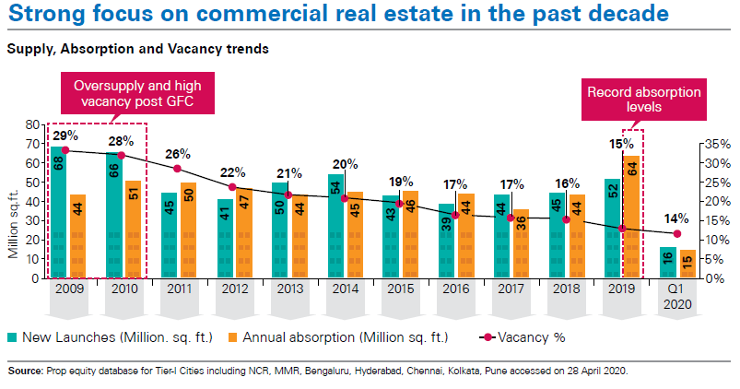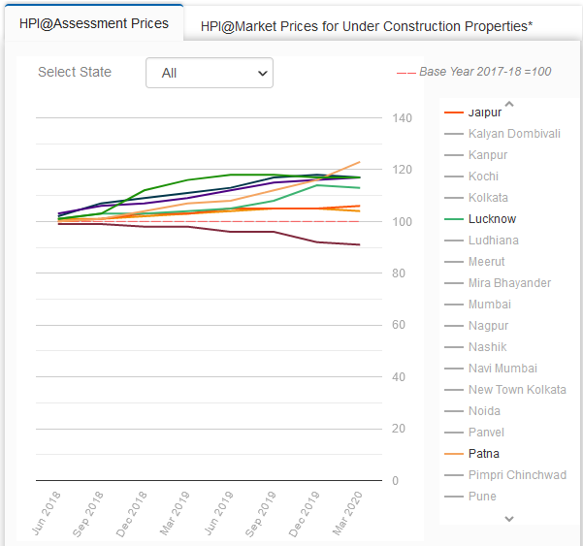This project, will be really helpful for the millennial who are interested in making investments in real estate for better future and growth. With the current govt. initiatives such as smart cities, emphasis on the Tier-II cities which will led to decentralize the development on Pan-India basis.

References:

1. National Housing Bank ( <https://residex.nhbonline.org.in/nhb.aspx> )
2. KPMG: COVID-19: React, adapt and recover – The new reality
3. Classification of Indian cities: ( <https://en.wikipedia.org/wiki/Classification_of_Indian_cities> )